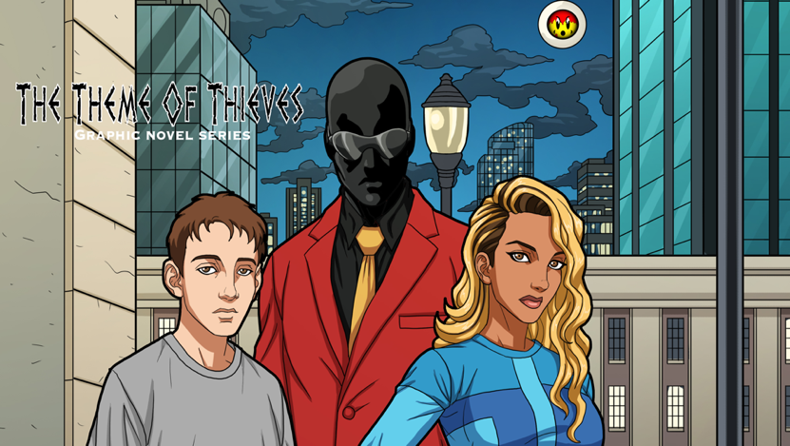

PITTSBURGH, PA. 1.25.2024 — Comicsburgh & Krayzehouse Development Media is pleased to announce that writer/creator D.P. Brown (Sammy & Sissy Protect People) and artist Dan Ekis(Soul Of The World, Odyssey Inc.) will team up with rising star colorist Alex Zief(Monster Matador) for the forthcoming comic book science fiction series The Theme Of Thieves. This thrilling new time travel adventure is produced by Krayzehouse Development Media and distributed through Comicsburgh will be on sale in comic book shops nationwide 2/21/24 and online at www.themeofthieves.com.
“I love to create. There is not a day that goes by where I am not thinking about some elements of this story. My inspiration for it came when I noticed in my observations of young people that they were lacking the knowledge of many aspects of history. My aim with this series is to tell an entertaining adventure with my main characters coming of age as they learn about aspects of history while bouncing around different time periods. My inspiration for this comic comes from my favorite TV shows Quantum Leap, Lost and The Wire,” says D. P. Brown. “I met Dan at a comic book convention in Pittsburgh who I believed had some really strong visuals in his book Soul of The World and those visuals matched with this exciting story just puts Thieves in a category of its own! The readers of my comic will find essential elements I put into a story, such as politics, race, religion and most of important to me strong, multi-layered characters. Great attention is paid to the colors, done by the talented colorist Alex Zief, with supervision by me and my team.”
The Theme of Thieves tells a story of a mysterious time traveler that comes and takes two young teens, who are coming of age, as they journey through different time periods in history. During their travels, they all work together to unravel the cause behind a disappearing of people, a phenomenon called “evanescence” that’s been happening since the 1700s and continues in present day. The stories in this comic book series and its companion website https://forthesakeofthecity.com are the stories of a broken and conflicted world trying to find a sense of hope while dealing with the evanescence phenomenon that is affecting politics, religion, families and life in general. As world tensions continue to escalate in the present, our heroes in the past gather clues to this mystery of evanescence that they are determined to solve. Will the heroes succeed and come back into the present in time to save the world from itself?
“I’m thrilled about this new adventure: I teamed up with D.P. as an artist on this project because of my faith in him as a storyteller and his debut writing a comic book story professionally, I couldn’t think of a better debut for DP,” says Ekis. “We started working on this project in a world which seemed much less hopeful during the pandemic. It’s amazing that he built up a story which appears to be intense and delicate at the same time, entertaining, sometimes harsh, and shocking, but also making people reflect on where we are and where we want to go in life.”
Ekis added: "It's great to be involved in this awesome adventure, which allows me to draw great characters. I loved the story from the first day I read the pitch, and I couldn’t be more excited about joining such a talented writer on this project. I can just say that The Theme of Thieves will be one of the most exciting comic books I've ever read!"
Issue #1 is 36 pages with cover drawn by Marvel Comics artist Ruben Gonzalez(Ant Man Season 1, Transformers). This intense, sci-fi thriller will project readers into a complicated world yet not very far from our own, with a story full of mystery, suspense and drama as the human condition is examined.

The Theme of Thieves #1 will be on sale in comic book shops nationwide 2/21/2024 and also available for purchase on www.themeofthieves.com day & date!

