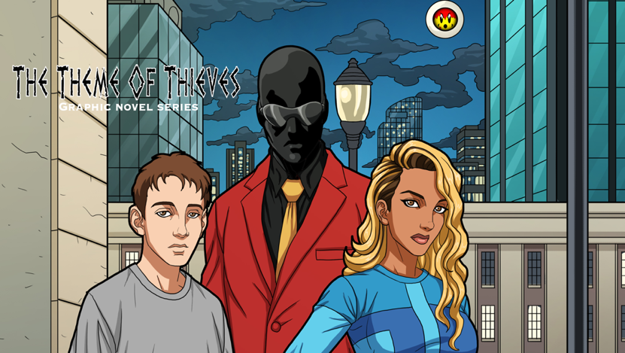

PITTSBURGH, PA. 10.13.2022 — Krayzehouse Development Media is pleased to announce that up and coming writer D.P. Brown (Sammy & Sissy Protect People) and artist Dan Ekis(Soul Of The World, Odyssey Inc.) will team up with rising star colorist Alex Zief(Monster Matador) for the forthcoming comic book science fiction series The Theme Of Thieves. This thrilling new time travel adventure is produced by Krayzehouse Development Media and is currently on sale at www.themeofthieves.com.
“I love to create. There is not a day that goes by where I am not thinking about some elements of this story. My inspiration for it came when I noticed in my observations of young people that they were lacking the knowledge of many aspects of history. Sure, they learn what they can in school but is it fun? My aim with these stories is to tell adventures with my main characters learning about themselves as the learn about aspects of history as the bounce around different time periods. My inspiration for that comes from the 80’s TV show classic Quantum Leap,” says D. P. Brown. “I met Dan at a comic book convention in Pittsburgh who I believed had some really strong visuals in his book Soul of The World and those visuals matched with this exciting story just puts Thieves in a category of its own. The readers of my books will find essential elements I put into a story, such as politics, race, religion and most of important to me strong female characters. Great attention is paid to colors, done by talented colorist Alex Zief, with supervision by me and my team.”
The Theme of Thieves tells a story of a mysterious time traveler that comes and takes two young teens, who must both overcome their cynicisms of the world as they venture through different time periods in history. As they come of age in their adventures, they all work together to unravel the cause behind the evanescence phenomenon(disappearing) that’s been happening since the 1700s in present day. The stories in this comic book series and its companion website are the stories of a broken and conflicted world trying to find a sense of hope in a disappearing phenomenon they cannot control.
​
These time traveling individuals will encounter the best parts of history and the worst parts as they try to solve the mystery of why people have been disappearing throughout history and its effects on politics, religion, culture as world tensions continue to escalate all the way to the present.
“I’m thrilled about this new adventure: I teamed up with D.P. as an artist on this project because of my faith in him as a storyteller and his debut writing a comic book story professionally, I couldn’t think of a better debut for DP,” says Ekis. “We started working on this project in a world which seemed much less hopeful during the pandemic. It’s amazing that he built up a story which appears to be intense and delicate at the same time, entertaining, sometimes harsh, and shocking, but also making people reflect on where we are and where we want to go in life.”
Ekis added: "It's great to be involved in this awesome adventure, which allows me to draw great characters. I loved the story from the first day I read the pitch, and I couldn’t be more excited about joining such a talented writer on this project. I can just say that The Theme of Thieves will be one of the most exciting comic books I've ever read!"
This intense, sci-fi thriller will project readers into a complicated world yet not very far from our own, with a story full of mystery, suspense and drama as the human condition is examined.

The Theme of Thieves #1 & 2 is now available for purchase on www.themeofthieves.com and in stores coming soon 2023!

